**CREAR VIRTUAL ENVIRONMENT NODE JS**

erick@ERICK MINGW64 ~/Documents/DEVELOPER/WEB_RTC_VIDEO_CHAT/SIGNALING_SERVER

$ npm init

This utility will walk you through creating a package.json file.

It only covers the most common items, and tries to guess sensible defaults.

See `npm help init` for definitive documentation on these fields

and exactly what they do.

Use `npm install <pkg>` afterwards to install a package and

save it as a dependency in the package.json file.

Press ^C at any time to quit.

package name: (signaling_server)

version: (1.0.0)

description: Signaling Server WebRTC

entry point: (app.js)

test command:

git repository:

keywords:

author: Erick Zabala

license: (ISC)

About to write to C:\Users\erick\Documents\DEVELOPER\WEB_RTC_VIDEO_CHAT\SIGNALING_SERVER\package.json:

{

"name": "signaling_server",

"version": "1.0.0",

"description": "Signaling Server WebRTC",

"main": "app.js",

"scripts": {

"test": "echo \"Error: no test specified\" && exit 1"

},

"author": "Erick Zabala",

"license": "ISC"

}

Is this OK? (yes)

erick@ERICK MINGW64 ~/Documents/DEVELOPER/WEB_RTC_VIDEO_CHAT/SIGNALING_SERVER

$

**EJECUTTAR DE FORMA AUTOMATICA Y MANUAL**

erick@ERICK MINGW64 ~/Documents/DEVELOPER/WEB_RTC_VIDEO_CHAT/SIGNALING_SERVER

$ node app.js

hola Erick!!!

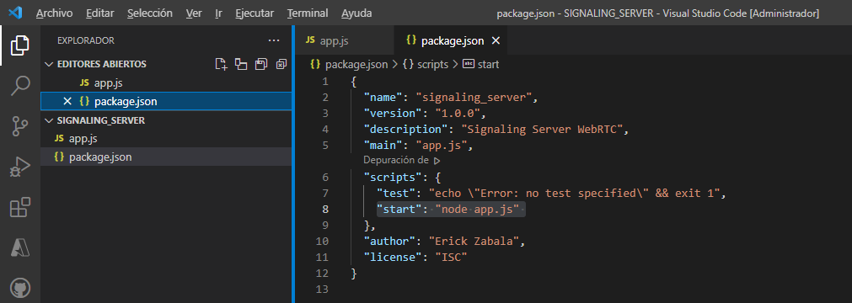

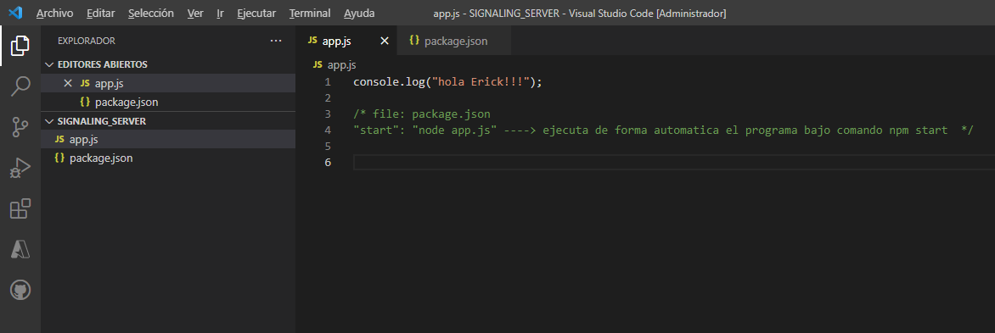

erick@ERICK MINGW64 ~/Documents/DEVELOPER/WEB_RTC_VIDEO_CHAT/SIGNALING_SERVER

$ npm start

> signaling_server@1.0.0 start C:\Users\erick\Documents\DEVELOPER\WEB_RTC_VIDEO_CHAT\SIGNALING_SERVER

> node app.js

hola Erick!!!

INSTALAR DEPENDENCIAS

EJEMPLO INSTALANDO UNA DEPENDENCIA

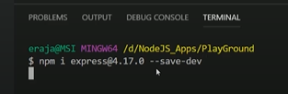

**VERSION DE NODE JS**

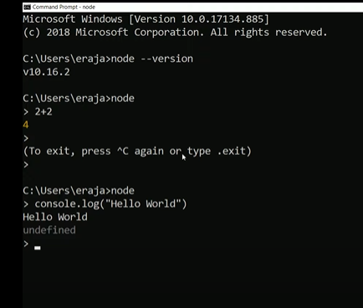

**WEBSOCKET EN NODE JS**

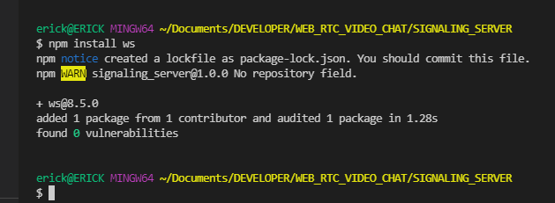

npm install ws